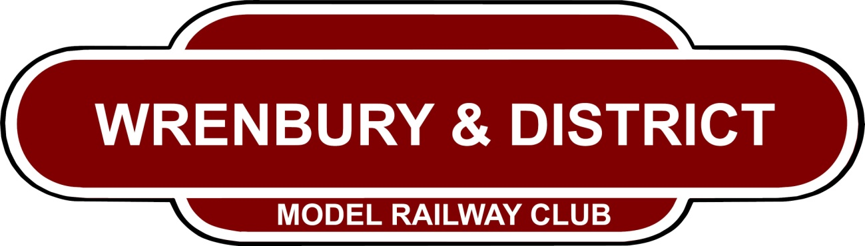
Hon President: Patrick Hope Johnstone – Earl of Annandale & Hartfell
Chairman: Adrian Finney – contact through http://www.wrenburymodelrailwayclub.btck.co.uk/
Secretary: David J Houghton 2 Fairview Park, Station Road, Wrenbury CW5 8HR
01270 781113 - davidandjoy@uk2.net
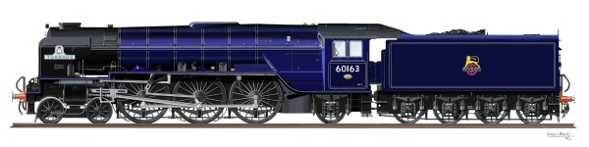
OPEN DOORS EVENT
Friday 30th June 7pm to 9.30pm
Saturday 1st July 9.30am to 4.30pm
Come and see the work in progress
on our three club layouts in the Village Hall
Cholmondeley Road Wrenbury CW5 8HG

See Digital Control 00 locos with sound chips fitted.
plus a visiting 0 gauge layout CHELAGASA TOWN
a visiting 00 layout & 3 visiting N gauge layouts.
+ 2 miniature traction engines (Saturday subject to weather)
..
Die-cast vehicles, many model railway items,
DVDs, books, magazines & jigsaws for sale.
We even have a wooden railway for the younger children.
FREE entry - refreshments available.
..

