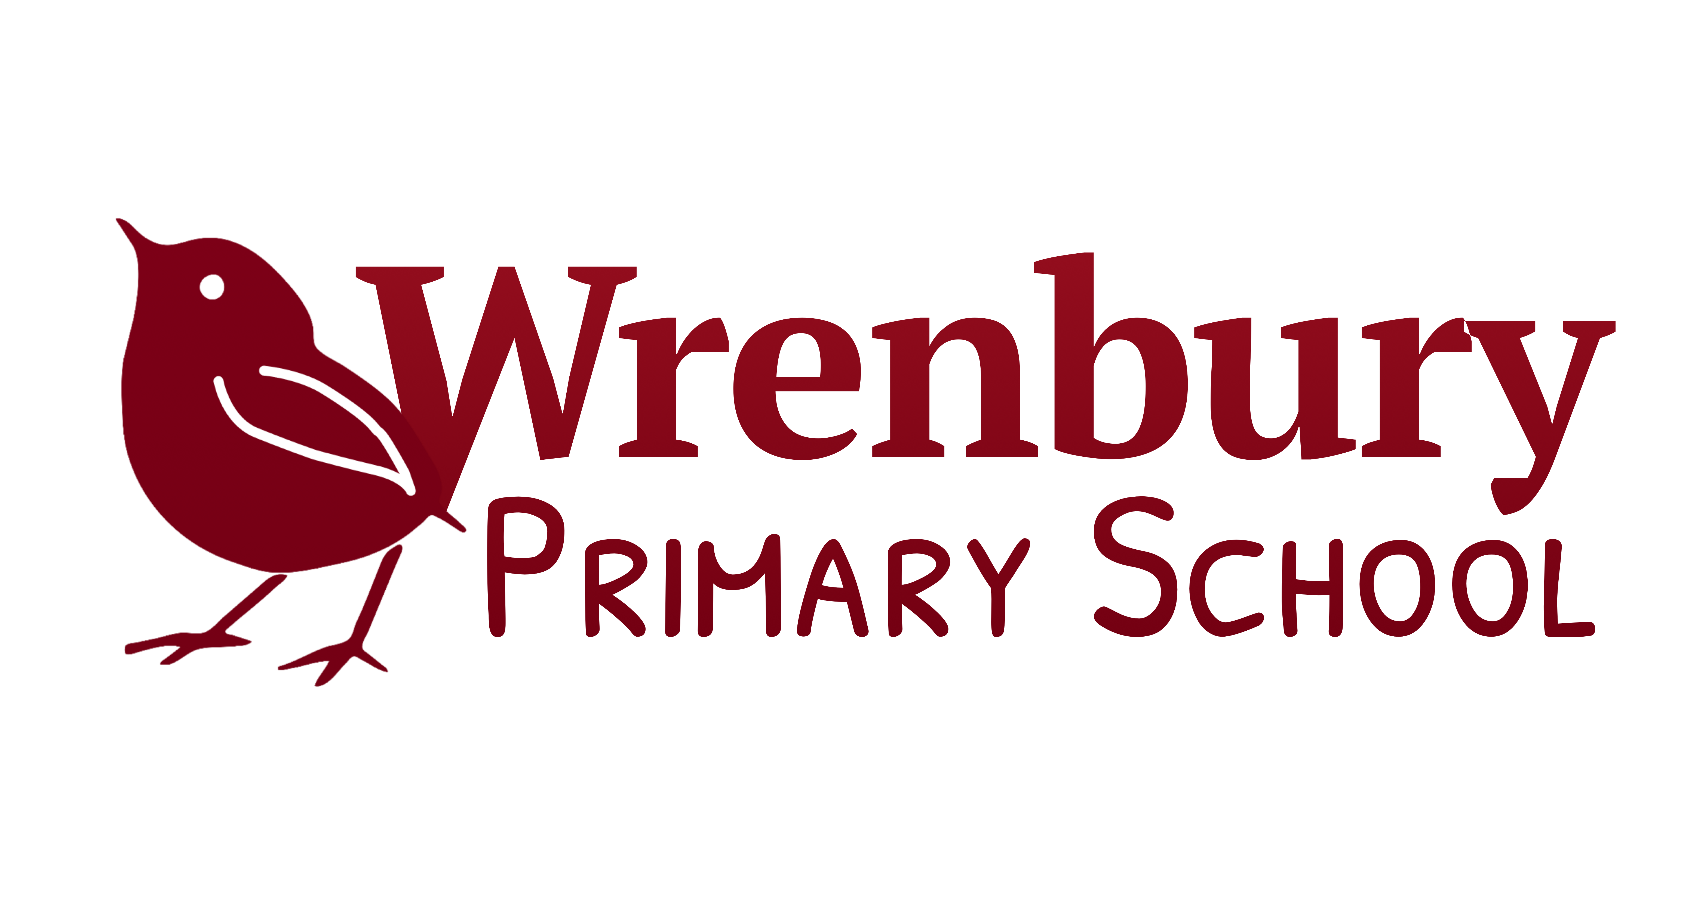
'...where we all matter.'

Relationship and Sex Education Policy
(This policy should be read in conjunction with the school's safeguarding and child protection policies, anti-bullying and behaviour policies and the e-safety policy)

1 Introduction
1.1 First and foremost, Wrenbury Primary School believes that Relationship and Sex Education (to be referred to as RSE throughout the policy) needs to be a highly personalised area of the curriculum, which not only supports our pupil's health, emotional and social well-being but also their safety. There will be a baseline of provision for all children taught through PHSE, Science, PE and e-safety. However, children's own varied and sometimes highly complex experiences of relationships, the varied way in their bodies change and grow, and their own questions about boys, girls and sex can mean that we bespoke what we teach to the needs of particular groups or individuals. This will always be done in full collaboration with parents and carers.
2. Definition of RSE: Relationship and Sex Education
2.1 Sex and Relationship Education (SRE) has been renamed as Relationship and Sex Education (RSE) to emphasise the relationships aspect of RSE. This was one of the recommendations from the Commons Education Committee (Feb 2015). Relationship and Sex Education is not just learning about growing up, changes and reproduction. It is also about enabling children to feel good about themselves and the choices that they make, make and maintain good relationships with others and to understand about human sexuality. This involves helping children to gain knowledge, develop skills and form positive beliefs and attitudes.
2.2 Knowledge and Understanding including: emotional, social and physical aspects of growing up, puberty, reproduction and pregnancy, similarities and differences between males and females, parts of the human body including male and female reproductive parts, gender stereotyping and discrimination, different families, different types of relationships, healthy and unhealthy relationships and where to get help if needed.
2.3 Personal and Social Skills including: talking and listening to others, managing emotions, making friends and managing friendships, forming and maintaining loving, caring and respectful relationships, developing self-respect and empathy for others, respecting the differences between people, resilience to cope with change, making responsible and safe decisions, including decisions they make online.
2.4 Attitudes and Values including: feeling positive about growing up, the importance of respect, care and love, the value of family life, the importance of stable and loving relationships, including marriage (both heterosexual and gay) and civil partnership, respect for rights and responsibilities in relationships, acceptance of difference and diversity, promoting gender equality.

3. Purpose of the Relationship and Sex Education Policy
3.1 Producing an up to date RSE policy is the statutory responsibility of the governing body. This policy has been drawn up in collaboration with parents, staff and governors to ensure that the views of all members of our school community have been considered.
The purpose of this policy is to:
- Give information to parents and carers, staff, governors and outside visitors about the content, organisation and approach to teaching RSE
- Enable parents and carers to support their children in learning about RSE
- Give a clear statement on what the school aims to achieve from RSE, the values underpinning it and why it is important for our pupils at Wrenbury Primary School.
- Be clear about how we address RSE in our school context.

4. Why teach RSE at primary school?

- It provides an opportunity to talk about feelings and relationships
- It promotes the skills necessary for effective communication and loving, caring, respectful and happy relationships
- It helps develop positive attitudes, values and self-esteem and challenges negative attitudes and prejudices
- It helps make sense of misinformation in the media and from peers
- It prepares children for the physical and emotional changes that will take place at puberty
- It protects children from sexual exploitation including online
- It is a statutory part of the science curriculum covering the biological aspects of RSE

5. Aims and objectives
We teach children about:

- the physical development of their bodies as they grow into adults;
- the way humans reproduce;
- respect for their own bodies and the importance of sexual activity as part of a committed, long-term, and loving relationship;
- the importance of family life;
- moral questions;
- relationship issues;
- respect for the views of other people;
- sexual abuse, and what they should do if they are worried about any sexual matters.

6. Context
6.1 We teach about sex in the context of the school's aims. While RSE in our school means that we give children information about sexual behaviour, we do this with an awareness of the moral code, and of the values that underpin all our work. We teach RSE on the understanding that:
- it is taught progressively so that children are taught about RSE in an appropriate way for their age and in the context of stable relationships and family life;
- it is part of a broad and relevant curriculum which is underpinned by spiritual, moral, social and cultural education (SMSC);
- children should be taught to have respect for their own bodies and those of others;
- children should learn about their responsibilities to others, and be aware of the consequences of sexual activity;
- it is important to build positive relationships with others, involving trust and respect;
- children need to learn the importance of self-control.

7 Organisation
7.1 We teach RSE through different aspects of the curriculum. While we carry out the main RSE in our personal, social and health education (PSHE) curriculum, RSE is also covered through other subject areas (e.g. science and PE) which we believe contribute significantly to children's knowledge and understanding of their own bodies, and how they are changing and developing.
7.2 In PSHE, we use the Social and Emotional Learning (SEAL) resources. These are themed across the year and help children to develop their self awareness and social skills, to manage their feelings and have empathy and to look at motivation. We teach children about relationships, and we encourage children to discuss issues. We teach about the parts of the body using the correct terminology, how they work and how to keep our bodies clean, healthy and safe. We explain to the children in Y5 and 6 what will happen to their bodies during puberty.
7.3 In both Key Stages, we follow the new national curriculum for science. Some of the area of science relate to the specific teaching of how animals, including humans, move, feed, grow and reproduce, and we also teach them about the main parts of the body. Children learn to appreciate the fact that people are not all the same, and that we need to respect each other. In upper Key Stage 2, we teach about life processes and the main stages of the human life cycle, in greater depth, including puberty and reproduction.
7.4 In Year 5 and 6, we place a particular emphasis on sex education, as many children experience puberty at this age. We liaise with the school nurse about suitable teaching resources to use with our children in these lessons. Boys and girls are taught about puberty separately. Questions that arise are answered with sensitivity and care. By the end of Key Stage 2, we ensure that both boys and girls know how their bodies change during puberty, what menstruation is, and how it affects women and how babies are born. We always teach this with due regard for the emotional development of the children.
7.5 We give parents the opportunity to opt out of this session and will, if requested, provide information about the content.
7.6 In PE, we teach children about the need to be healthy and active. We also teach the children that as they develop their body responds to intense activity by perspiring and consequently the need to keep their bodies clean.

8 The Role of Parents
8.1 The School is well aware that the primary role in children's RSE lies with parents and carers. We therefore wish to build a positive and supporting relationship with the parents of children at our school, through mutual understanding, trust and cooperation. To promote this objective, we:
- consult with parents who are representative of our school community when reviewing of the school's RSE policy
- inform parents about the school's RSE policy and practice;
- answer any questions that parents may have about the RSE of their child;
- take seriously any issue that parents raise with teachers or governors about this policy, or about the arrangements for RSE in the school;

We believe that through this mutual exchange of knowledge and information, our children at Wrenbury will benefit from being given consistent messages about their changing bodies and their increasing responsibilities.
6.2 Parents have the right to withdraw their child from all or part of the RSE programme that we teach in our school. If a parent wishes their child to be withdrawn from RSE lessons, they should discuss this with the Headteacher, and make it clear which aspects of the programme they do not wish their child to participate in. The school always complies with the wishes of parents in this regard.

7 The Role of other Members of the Community
7.1 We encourage other valued members of the community to work with us to provide advice and support to the children with regard to health education. In particular, members of the Local Health Authority, such as the school nurse and other health professionals, give us valuable support with our RSE programme. Other people that we call on include local clergy, social workers and youth workers.

8 Confidentiality
8.1 Teachers conduct RSE lessons in a sensitive manner, and in confidence. However, if a child makes a reference to being involved (or being likely to be involved) in sexual activity, then the teacher will take the reference seriously, and deal with it as a matter of child protection. Teachers will respond in a similar way if a child indicates that they may have been a victim of abuse. They will not try to investigate, but will immediately inform the named person for child protection issues about their concerns. The Headteacher will then deal with the matter in consultation with health care professionals (see also our policy on Child Protection).

9 The Role of the Headteacher
9.1 It is the responsibility of the Headteacher to ensure that both staff and parents are informed about our RSE policy, and that the policy is implemented effectively. It is also the Headteacher's responsibility to ensure that members of staff are given sufficient training, so that they can teach about sex effectively, and handle any difficult issues with sensitivity.
9.2 The Headteacher liaises with external agencies regarding the school RSE programme, and ensures that all adults who work with our children on these issues are aware of the school policy, and work within its framework.
9.3 The Headteacher monitors this policy on a regular basis, and reports to governors, when requested, on the effectiveness of the policy.

10 Monitoring and Review
10.1 The Personal development, Behaviour and Welfare Committee of the governing body monitors the impact of our RSE policy on an annual basis. This committee reports its findings and recommendations to the full governing body, as necessary, if the policy needs modification. The Personal development, Behaviour and Welfare gives serious consideration to any comments from parents about the RSE programme, and makes a record of all such comments.
10.2 This policy will be reviewed every two years, or earlier if necessary.

Signed: Jenny Davies
Chair of Governors

Date: Spring 16 (FGB)
Review Date: Spring 2018

Appendix 1:

SEAL (Social and Emotional Learning)
Each year group covers the same themes at the same time to promote a whole school progressive approach and a consistent language when talking about social and emotional well-being. This also means that some aspects of the work will be covered through whole school assemblies or by visiting speakers.

SEAL focuses on 5 key areas: Self-awareness; Managing feelings; Social Skills; Empathy; Motivation

School Calendar | Theme | SEAL- focus
Autumn Term
September/October | New beginnings | Empathy  Self-awareness  Motivation  Social skills
November/December | Getting on and falling out | Managing feelings  Empathy  Social skills
One-two weeks to coincide with anti-bullying week (November) | Say ‘no’ to bullying | Empathy  Self-awareness  Social skills
Spring Term
January / February | Goal for goals! | Motivation  Self- awareness
February / March | Good to be me! | Self –awareness  Managing feelings  Empathy
Summer Term
March/April | Relationships | Self- awareness  Managing feelings  Empathy
June / July | Changes | Motivation  Social skills  Managing feelings

Appendix 2:
From the Science New Curriculum 2014 Programme of Study, the following are specifically related to the teaching of RSE. These will be taught with the appropriate year group as part of the science teaching:
Y1
- identify, name, draw and label the basic parts of the human body and say which part of the body is associated with each sense.
Pupils should have plenty of opportunities to learn the names of the main body parts (including head, neck, arms, elbows, legs, knees, face, ears, eyes, hair, mouth, teeth) through games, actions, songs and rhymes.

Y2
- notice that animals, including humans, have offspring which grow into adults
(They should also be introduced to the processes of reproduction and growth in animals. The focus at this stage should be on questions that help pupils to recognise growth; they should not be expected to understand how reproduction occurs.)

Y5
- describe the changes as humans develop to old age.
(Pupils should draw a timeline to indicate stages in the growth and development of humans. They should learn about the changes experienced in puberty. Pupils could work scientifically by researching the gestation periods of other animals and comparing them with humans; by finding out and recording the length and mass of a baby as it grows.)

Y6
- recognise that living things produce offspring of the same kind, but normally offspring vary and are not identical to their parents

