**PE**

**‘He did not hold the reins. The pony could have jumped away, but he didn’t.’**

In PE this term we will be continuing to build on our current PE skills and fitness through a range of activities to improve flexibility, strength and fitness. We will also be working on the skills required to play tennis, alongside improving our throwing and catching skills.

**Art**

***‘No pictures,’ he growled. ‘if tepee, then need pictures.’***

Our Art work this term will be focused around Native Americans, we will look at how different tribes communicated through the use of art, discovering the use of patterns, shapes and colours. We will be transferring this knowledge to a range of art works, including fabric painting.

**Literacy**

**‘The Indian responded with a noise like a snarl. There was no more conversation for the next few minutes.’**

Our Literacy this term will be led by another very exciting class text, ‘The Indian in the Cupboard’, Lynne Reid Banks. We will read our text throughout the term and use parts of it as inspiration for our writing, as well as looking at the style of writing, vocabulary, punctuation and grammar used throughout. Alongside our class text we will look at a wide range of other fiction and non-fiction texts linked to our topic on Native Americans

Over this term, we will cover a range of genres, including narratives using punctuated speech, instructions, traditional tales, persuasive texts and explanation texts. Within this we will be developing our vocabulary, exploring words and their meaning.

We will be developing our use of punctuation by using commas consistently and exploring direct speech; along with this we will continue to utilise a wide range of sentence structures. Conjunctions, extending sentences, commas and editing our writing are main focuses for this term.

This term we will continue to work on writing independently, at length for a set period of time.

**Science**

***‘Good sleep happen. Cold ground. Need blanket. Food. Fire.’***

**Light**

* Identify the uses of light
* Light reflected from surfaces to allow us to see
* Shadows (changing size of shadows)

**Rocks**

* Different types of rocks and their formation
* Fossils (from around the world)

**Animals including humans**

* Nutrition
* Skeletons/muscle
* Digestive system
* Teeth

**Computing**

We will develop our programming skills through the use of Scratch, we will learn how to control and adjust the programme. We will create algorithms to be tested and then de-bug them as necessary to create the desired outcome. We will be learning the necessary vocabulary to support programming.

***‘It was, without a doubt, very kind of /Patrick to give Omri anything at all, let alone a second hand plastic Red Indian.’***

**History**

In History this term we will be exploring Native Americans over time. We will be discovering the different tribes and their ways of life over time. We will be looking at significant times during Native American history and put these into chronological order.

***‘Iroquois brave. Son of Chief.’***

**Geography**

Within Geography this term we will be exploring America, including types of settlements linked to Native American tribes, the weather within America making links to how tribes live and the distribution of natural resources, again with links to the mobility of Natïve Americans.

**Music**

***‘He uttered a few sounds, half curses and half just noises.’***

Throughout this term Base 3 will be investigating the structure of music and how it contributes to sound and also looking at performance, what makes a good performance and how to perform music to engage the listener.

**Maths**

**‘*Little Bull proudly held up all ten fingers. Then he closed his fists, opening them again with another lot of ten.’***

This term in maths we will continue to follow the year 3 and 4 new Maths National Curriculum.

We will be building on top of our previously learnt skills daily through short morning activities that encourage children to develop their mental methods and written methods for Maths. This will enable us to move further forwards with a wider range of problem solving. We will be looking at problems with more than one step within which we have to decide which operation is needed.

***‘The crate was a metre square, made of planks.’***

Linked to our Native American topic, we will be measuring within DT, ordering dates in History and collecting types of data about Native American tribes.

**RE**

Our RE this term will focus on Religious artefacts and Islam, family life.

**D&T**

***‘I’ll make you a proper tepee.’***

***‘Tepee!’ the Indian shouted. ‘I not live tepee.’***

Our DT project this term will be creating our very own model Tepee. To do this we will be measuring and cutting dowel to size and creating a fabric outer layer. We will also have a go a creating Dream catchers and a Totem pole.

**The Indian in the Cupboard**

**Lynne Reid Banks**

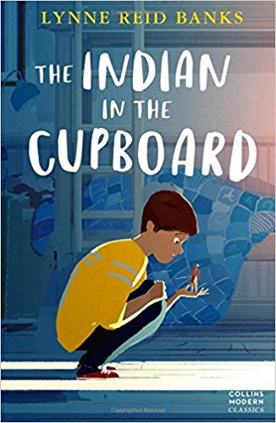

**Planning Overview**

**Summer 2017 – Native Americans**

**Base 3/year 3 & 4**

**Miss Phillips**