**D&T**

***‘We’ll get to know this boat like she’s one of us. She’s a forty-two foot, Bowman.’***

Our DT project will follow our journeys theme through boats. We will be following the 5 stage process to create a boat that will float on water. We will be exploring different materials that we could use and ways of joining these together.

**RE**

***'…not a miracle, just faith.' p161***

Our RE this term will focus on the Parables followed by caring for creation.

**PE**

***‘Afterall, I had nowhere to swim to’ p 47***

In PE this term we will have a series of swimming lessons. We are also going to be continuing to build on our current PE skills and fitness through a range of activities to improve flexibility, strength and fitness. We will also be working on Kicking skills and games that help us to develop kicking skills further. We utilise the Amaven planning programme which is tailored to the children’s needs.

**Art**

***‘He painted on large shells but, much to my disappointment, he never showed me what he had done.’***

Our Art work this term will be related to historic journeys and modes of transport used. To create this art work we will be developing the printing technique and observing other print artwork. Alongside printing we will be creating 3D artwork through layering to add texture and depth to our work.

**Kensuke’s Kingdom**

***Michael Morpurgo***

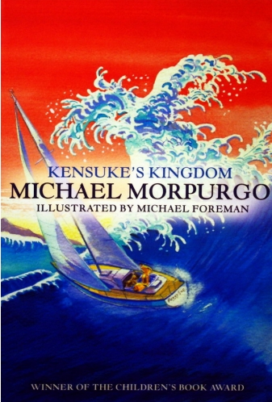

**Planning Overview**

**Spring 2017 – Journeys and inventions**

**Base 3/year 3 & 4**

**Miss Phillips**

**Maths**

***‘We’re hundreds of miles out in the Indian ocean.’***

This term in maths we will continue to follow the year 3 and 4 new Maths National Curriculum.

We will be building on top of our previously learnt skills daily through short morning activities that encourage children to develop their mental methods for Maths. This will enable us to move onto the written formal methods for addition, subtraction and multiplication. Alongside this we will be integrating a wide range of problems that enable children to apply their skills.

***‘She taught me how to take compass bearings and plot a course on the chart.’***

Linked to our Journeys topic we will be using coordinates and grid references to plot journeys on maps and find specific places on a map. We will also look at calculating distance of journeys and the time it could take.

**Science**

**Light**

* Identify the uses of light
* Light reflected from surfaces to allow us to see
* Shadows (changing size of shadows)

**Forces (linked with DT)**

* Movement of different surfaces
* Different types of forces and how forces are produced

**Rocks**

* Different types of rocks and their formation
* Fossils (from around the world)

**Music**

***‘All Kensuke had to do was sing and they’d come.’***

Throughout this term we will be exploring the beat within music, identifying the number of beats within a bar of music and then applying this to composition and performance. We will also explore different sounds, which link to the sounds of journeys.

*Year 3 will be taking part in the Singfest performance in March*

**Literacy**

***‘I found a sharp stone, knelt down and scraped out my message on the rock beside the bowls.’***

Our Literacy this term will be led by another very exciting class text, ‘Kensuke’s Kingdom’, Michael Morpurgo. We will read our text throughout the term and use parts of it as inspiration for our writing, as well as looking at the style of writing, vocabulary, punctuation and grammar used throughout. Alongside our class text we will look at a wide range of other fiction and non-fiction texts.

Over this term, we will cover a range of genres, including **narratives, balanced arguments, instructions and poetry**. Within this we will be developing our vocabulary, exploring words and their meaning.

We will be developing our use of punctuation by using commas consistently and exploring direct speech; along with this we will continue to utilise a wide range of sentence structures. Adverbs and different sentence starters are a main focus for this term.

This term we will continue to work on writing independently, at length for a set period of time.

***‘We took on a lot of stores and water for the long haul to South Africa. Mum says we need to keep South, in the west-to-east South Atlantic current.’***

**History**

In History this term we will be exploring significant explorers who have travelled to various parts of the world and the modes of transport that they have used over time. We will also touch on developments in transport.

**Geography**

***'We could sail around the world. Africa. South America. Australia. The Pacific.' p10***

In Geography we will be developing our map skills by following the Journey Michael takes from our class text. We will be using a world map to map out the journey and explore some of the regions of the world that he visits. Within this we will be finding four and six-figure grid references.

**Computing**

***‘…at computers and what they could do’ p139***

We will develop our programming skills through the use of Scratch, we will learn how to control and adjust the programme. We will create algorithms to be tested and then de-bug them as necessary to create the desired outcome. We will be learning the necessary vocabulary to support programming.