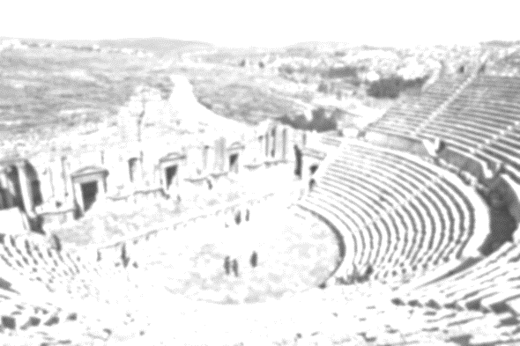

**PE**

***‘But his chest was still heaving and sweat was pouring down his body…’ (p19)***

**In PE, this term we will are going to be building on our current PE skills and fitness through a range of activities to improve flexibility, strength and fitness. We will also be working on bouncing skill and playing a range of games to develop these.**

**Music**

***‘From behind them came the distinctive clank of an ox cart bell and the grinding of iron wheel rims on the stone road.’ (p35)***

**Throughout this term we will be exploring beat: creating sequences; perform steady rhythms; combining rhythms in layers. We will also be exploring sound: creating call and response sequences. Linking to our Roman theme, we will look at the work of composers such as Verdi and the operas the created.**

***Year 3 and 4 will be involved in brass instrument tuition this term.***

**D&T**

***‘…he could hear the sound of whip-cracks and wagon wheels.’ (p19)***

**Our DT project this term will allow us to understand and use the 5-stage process, with the focus being to design and make a working Roman catapult**

***‘” In Brtiannnia?” Ursula said. “But that’s the edge of the world!”’ (p32)***

***‘” They’re not regular legionaries,” Fronto said in Juba’s ear. “It must be a century of auxiliary archers. You can tell by their oval shields and their bows and arrows.”’ (p144)***

* **The Roman Empire and its impact on Britain**
* **Julius Caesar’s attempted invasion in 55-54BC**
* **Roman Empire by AD42 and the power of its army**
* **Successful invasion of Claudius and conquest of Britain**
* **‘Romanisation’ of Britain**

**Geography**

* **Identifying countries and capital linked to Roman Empire**
* **Physical and human features of Italy as a European country**

***The topics in Geography will make links to Italy and its similarities and differences with the UK. Technical vocabulary will be developed and used throughout.***

**Maths**

***‘He opened her money pouch and poured out ten silver coins.’ (p204)***

**This term in maths we will be following the year 3 and 4 new Maths National Curriculum.**

**We will be building on top of our previously learnt skills and will be focusing on securing the basic skills that will allow us to progress through maths, especially number bonds, counting, times tables and generating efficient methods to use.**

**Linked to our Roman, we will look at Roman Numerals**

**RE**

***‘”Do you want to ask for God’s blessing?”’ (p216)***

**Our RE this term will focus on the Christian faith looking at Christian values, beliefs and teachings focussing on hope and descriptions of God as sustainer, creator and saviour.**

**Computing**

**We will develop our programming skills using Scratch, we will learn how to control and adjust the programme. We will create algorithms to be tested and then de-bug them as necessary to create the desired outcome. We will be learning the necessary vocabulary to support programming.**

**Science**

***‘The only thing wrong with the light. It was grey and soft, and cast no shadows.’ (p109)***

**Light (Year 3)**

**This term we will be exploring light, including needing light to be able to see and that light is reflected from surfaces. We will investigate shadows, how they are formed and look for patterns in the way the size of shadows change.**

***‘As they got closer to the trees, the sound of marching feet grew closer.’ (p144)***

**Sound (Year 4)**

**We will be looking at how sounds are made and that vibrations travel through different mediums to reach the ear. We will look for patterns between the pitch of a sound and features of the object that produces it and patterns between the volume of a sound and the strength of the vibrations**

**Art**

**‘*The black and white mosaic floor had a pattern of diamonds and squares.’ (p153)***

**Part of our Art work this term will be based on mosaics discovered during Roman Times. We will be exploring the work done by the Romans, observing the techniques used and the use of colour. We will then apply these techniques and styles to our mosaics.**

**Also, we will be creating a sculpture of Italy using clay ensuring a 3D image highlighting the geographical features of the country.**

Literacy

*‘In the flickering light of a bronze oil lamp he could see that she was wearing his father’s winter cloak even though it was a warm summers’ night.’ (p1)*

**Our Literacy this term will be led by our captivating class text, ‘Escape from Rome’, Catherine Lawrence. We will read our text throughout the term and use parts of it as inspiration for our writing, as well as looking at the style of writing, vocabulary, punctuation and grammar used throughout. Alongside our class text we will look at a wide range of other fiction and non-fiction texts.**

**Over this term, we will cover a range of genres, including narratives, diary writing, descriptive writing, newspaper reports. Within this we will be developing our vocabulary, exploring words and their meaning.**

**We will be securing our use of the basic punctuation (capital letters, full stops and commas) and extending our understanding of more complex punctuation (speech marks); this will allow us to move onto developing our sentence structures, using more than one clause and starting our sentences in different ways. Conjunctions will also be a focus during this term, ensuring that they are used correctly and a variety are used throughout a piece of writing.**

**This term we will be working hard on writing independently, at length for a set period of time.**

**Planning Overview**

**Autumn 2017 – The Roman Empire and its Impact on Britain**

**Base 3/year 3 & 4**

**Mrs Heaton**

**Escape from Rome**

**Catherine Lawrence**

