[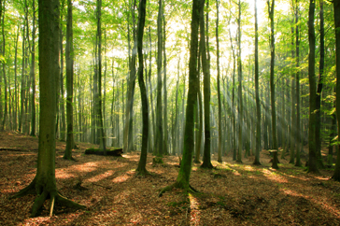](http://www.google.co.uk/url?sa=i&rct=j&q=&esrc=s&source=images&cd=&cad=rja&uact=8&ved=0ahUKEwjd4LiK_8rOAhXGvhQKHdIyDDcQjRwIBw&url=http://www.lymeneuroborreliosisprogram.org/html/about-lyme-disease/how-common-is-it.html&psig=AFQjCNHVF5KJnW9Za7_loKquTLWZNWZ7vQ&ust=1471610667219705)

**Computing**

We will be learning to understand and give directions by programming digital devices

**English**

**Spoken** **Language /Reading /Writing /Handwriting /SPaG/ Phonics**

We will be following the Year 1 National Curriculum for English this year.

We will be using a variety of books, including We’re going on a Bear Hunt, The Gruffalo and the Gruffalo’s child, to support us with our learning and development of vocabulary. We will continue to follow the Jolly phonics programme and will be concentrating on correct letter formation and punctuation of sentences. The children will then be working on writing for a variety of purposes across different genres.

**R.E.**

* Introduction to the bible
* Christmas stories from around the world

**Music**

Autumn 1 – Ourselves – Exploring Sounds

Autumn 2 – Weather – Exploring Pitch

**Maths**

We will be following the Year 1 National Curriculum for Maths this year.

We will start with ensuring we have a good grasp of Number and place value before moving on to look at the four operation, fractions, measurement, properties of shape and position and direction.

**Art and Design**

* Painting – mixing colours, self-portraits
* Pencil drawing
* Andy Goldsworthy – Nature Art
* Printing

**History**

**Key Individuals**

Robin Hood

Guy Fawkes

**Key Events**

Bonfire Night

The Great Fire of London

**Geography**

-Naming and locating the four countries of the United Kingdom and their capital cities

-Looking at some forests in the UK

-Studying our local area of Wrenbury and comparing it to a small area in a non-European country

**Design and Technology**

* Bird Feeders
* Making Owls
* Collage
* Making scarecrows

**PSHE (SEAL)**

* New Beginnings
* Getting on and falling out

**Science** -

In science we will be:

* identifying and describing the basic structure of trees
* identifying and naming some wild plants and deciduous and evergreen trees
* Identifying and naming some common woodland animals
* Identifying and learning about nocturnal animals
* Identifying, naming ,drawing and labelling basic parts of the human body and looking at our senses
* Observing changes across the four seasons and describing weather associated to the seasons.

**Base 1 Year 1 2016/17 Autumn Term**

**Into the Woods…**

To include - About Me, Harvest, Autumn, Winter and Christmas

**P.E.**

* Ball Skills
* Dance
* Team Games