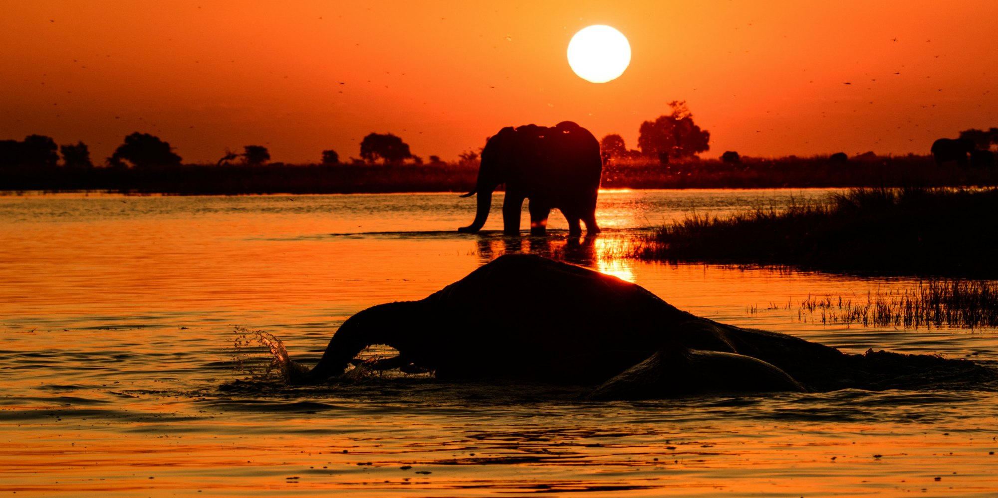

**Computing**

To create an animal drawing using paint

To write a sentence about their animal using word

To use simple programmes to aid learning

**Personal, Social and Emotional Development (Prime Area)**

* Children talk about how they and others show feelings, talk about their own and others’ behaviour, and its consequences, and know that some behaviour is unacceptable. They work as part of a group or class, and understand and follow the rules. They adjust their behaviour to different situations, and take changes of routine in their stride.
* Animal conservation
* Water aid

**Base 1 2016/17 Summer Term**

**Communities - Africa**

**Maths**

* Multiplication and division
* Addition and subtraction
* Reading and Writing (Yr1 – in words) numbers to 20
* Fractions
* Doubling, halving and sharing
* Pictograms
* Standard units of measure
* Problem solving using all 4 operations
* Consolidating Place Value
* Consolidating one less than

**Understanding of the World – Year 1 Science/History/Geography**

* Locate Africa and know some famous landmarks e.g. Victoria Falls, The Nile, Mount Kilimanjaro, Serengeti. (Key physical features)
* Compare the weather in Africa
* Compare a region of Africa to Wrenbury
* Explore languages spoken in Africa
* To compare a school in Africa to Wrenbury Primary School – including walk in the village
* To know a little about Nelson Mandela
* To know about safaris
* To know about African animals and classify them (fish, amphibian, mammals, birds and amphibians.
* Using senses to investigate African fruits – look at flesh, count seeds, plant seeds, taste etc.
* Planting fruit and vegetables in the school garden

**Literacy**

* Re-reading sentences to check they make sense.
* Using capital letters for proper nouns
* Ensuring sentences are punctuated with full stops, capital letters, question marks and exclamation marks
* Participating in discussion about what is read, taking turns and listening to each other
* Read words with contractions e.g. I’ll I’m
* -ed –es –s -ing -er -est word endings
* **We will be writing**

Setting descriptions

Descriptive writing about animals

Information texts

Leaflets - Persuasive

Acrostic poems

Narrative stories

Tinga Tinga tales

Recounts

**Communication and Language- Literacy (Prime Area)**

* We will read a variety of fiction and non -fiction books about Africa
* We will continue to develop our speaking and listening skills through class, group and 1:1 talk.

**Physical Development (Prime Area)**

* Athletics
* Sports day

**Expressive Arts and Design – Art/DT**

* Tinga Tinga Art
* Mandela patterns
* Sunset pictures
* African silhouette pictures
* Design and make a safari truck

**Music**

* African music – Listen to African music and discuss tempo and dynamics. Investigate African instruments.
* Call and response songs – Kye Kye Kule
* Animal noises – Can the children recreate on instruments?