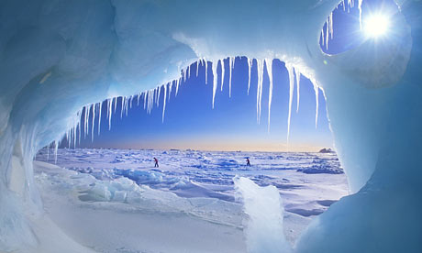

**Science**

In science we will be:

* Identifying and naming animals in the artic regions and learning about how these animals adapt to their habitat
* Investigating the physical properties of ice
* Learning about Healthy Eating
* Learning about the weather in artic regions

**Geography**

* Studying the world map and locating the Arctic regions and the UK
* Locating the countries in our text on the World map
* Compass Directions
* Continents, Oceans and Seas
* Weather in the Arctic

-

**PSHE (SEAL)**

* **Getting on and falling out -** Friendships
* **Going for Goals -** Resilience

**English**

**Spoken** **Language /Reading /Writing /Handwriting /SPaG/ Phonics**

We will continue to follow the Year 1 National Curriculum for English this year.

Our class book for this half term will be ‘Poles Apart’ which will be enriched by bringing in other relevant texts that link to out topic of Journeys. We will continue to follow the Jolly phonics programme and will be concentrating on correct letter formation and punctuation of sentences. The children will be working on writing for a variety of purposes to include story writing, character and setting description, poetry and diaries.

**R.E.**

Jesus the Story Teller

Easter - modern customs

**P.E.**

* Movement and Dance
* Hand/Eye Co-ordination
* Team Games
* Kicking skills - Sportscape

**Computing**

We will be learning to understand and give directions by programming digital devices and will be learning to use a paint package to use and create different effects.

**Design and Technology**

* Bird Feeders
* Dog Sleigh
* Polar Bear
* Penguin
* Baking
* Igloos

**Base 1 Year 1 2016/17 Spring 1**

**Journeys**

**Poles Apart**

**Art**

* Northern Lights Picture
* Night Sky Collages

**Music**

Spring 1: Exploring beat: Machines

Spring 2: Exploring performance : Travel

*Holst’s Planets*

*David Bowie – Star Man*

*Elton John Rocket man*

**Maths**

We will be following the Year 1 National Curriculum for Maths this year.

We will continue to consolidate place value along with addition and subtraction and then move on to looking at division, multiplication, fractions and position and direction.

**History**

**Key Individuals**

Captain Scott

Tom Crean

Ernest Shackleton

**Key Events**

Scott’s expeditions into the Antarctic regions