Wrenbury Primary School
'...where we all matter'
Nantwich Road
Wrenbury
Nr Nantwich
Cheshire
CW5 8EN

Dear Parents/Carers,

I would like to welcome you and your child back to the new school year; I hope you enjoyed the holidays and the children are well rested for a busy term. I am very much looking forward with the children in Base 2 with support from Mrs Winward, Mrs Taylor and Miss Rowlands.

Our Learning Journey for this term is based on a Charles Dickens text, ‘Oliver Twist’ (an adapted version); alongside this text we will be utilising a range of other quality texts to support our writing. We will be undertaking a range of exciting and interesting activities to find out as much as we can about The Victorian Era. Please see the termly plan for an overview of some of the learning we will undertake. If you feel you can contribute towards our Learning Journey in any way (artefacts / books / photos, support in class with a particular skill etc.) it would be warmly welcomed.

Expectations
As the children are now in their final year of Key Stage 1, it is important for the children to continue to develop their independence and start to take more responsibility for their learning. I will challenge and support your child in their learning, but will expect your child to do their very best and contribute positively to our class so that we all have a very rewarding and successful year. It is really important that we work together to help your child succeed both personally and academically.

Arrival at school
Good attendance is necessary for good progress. Please ensure your child arrives between 8:45 and 8:55am ready to start the day. Morning activities (Maths and Literacy based), which consolidate or challenge the children's learning, are set up for this time in readiness for registration of the class by 9am and a smooth transition into the literacy lesson.

Monies and messages
All monies and messages must come into school via myself to assist Mrs Rowlands in the office at the start of the day. It is important for the children to bring monies and messages in for themselves to help them become responsible and independent.

Outdoor clothing
We all know the weather is very changeable at this time of year. Therefore, appropriate clothing must be in school; in particular, a warm/waterproof coat should be brought/worn to school every day.

Snack
Snack will be available for Mrs Warner at break times each day, but if your child wants to bring a snack from home please ensure that it is a healthy snack as we are promoting healthy living.

Base 2 Timetable
We will have daily maths and literacy lessons with the afternoons dedicated to our Learning Journey, which will include science, art, design and technology, geography, history, music and ICT. There may be times where some of these subjects will be linked due to the nature of the task.
On Wednesday afternoon the children will receive an hour of RE with Mrs Clarke and an hour of Gymnastics provided by Total Gymnastics.
The children will continue to receive a 30 minute French lesson with Madame Sharpe, in their year groups, on Friday mornings.

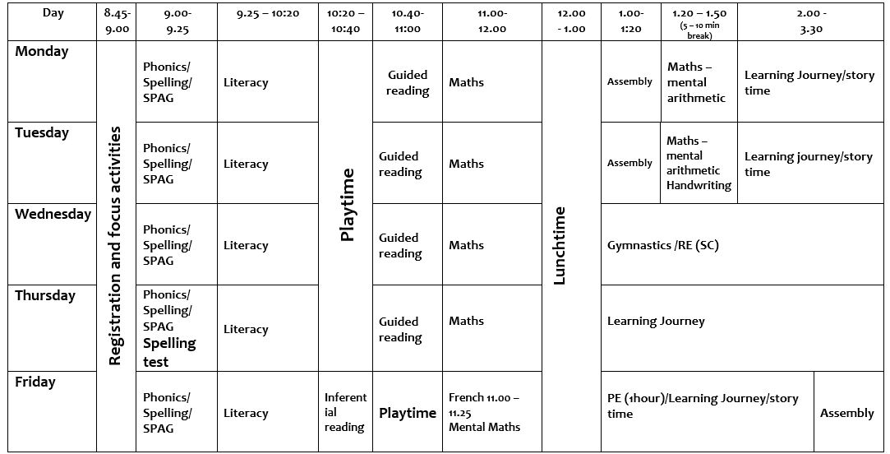

PE
PE kits (red top, black shorts/trousers, trainers, black jumper) must be in school EVERYDAY, especially Wednesday and Friday. PE kits should then be taken home to be washed over the weekend and brought back into school on Monday. There may be opportunities during our Learning Journey lessons for additional PE sessions so PE kits may be needed on other days. The children will be reminded that it is their responsibility to make sure PE kits are in school.

Homework
Once the children are settled and we have gained baseline assessments, regular homework will be sent on the following days:
- Literacy and Maths
Monday (Maths based) - Completed by Friday
Thursday (usually Literacy based) – Completed by Tuesday

- Times Tables -Test day Friday
To be practised at least 5 times throughout the week before the test.

- Spellings -Test day Thursday
To be practised 5 times throughout the week before the test.

- Daily Reading
Reading should be done daily, for at least 15 minutes, with comments written in the reading record.

Home time Arrangements
It is very important that the Home Time Arrangement sheet is completed and brought back to school. Please do notify me of any changes to home time arrangements at Meet or Greet in the morning or by phoning the school office.

Open door
My door is always open and I am always very happy to help should you have any concerns, wish to share information that is relevant to your child's well-being or require additional information regarding your child and their learning or progress. I will be at the door every morning or you can arrange a time to meet with me at a time that is convenient for the both of us.

There is a Pastoral Meeting booked for Wednesday 13th September, which will give you a chance to meet me and to find out, in more detail, about the rhythms, routines and expectations for your child in Base 2. I very much hope you will be able to attend as important information will be given about your child’s education.

I am looking forward to an exciting and enjoyable year with you and your child.

Miss Phillips

