**PE**

***‘…performing a marvellous stamping dance round the fire.’***

***-****develop their* ***throwing and catching skills*** *with Sportscape and Mr Sargeant*

***-****develop their* ***fitness and stamina*** *with Sportscape and Mr Sargeant*

**RE with Mrs Clarke**

***‘…offering up loud chanting prayers to the spirits…’***

- explore **Islam**

**SUMMER 2017**

**Base 4 Y4/5**

**The children will...**

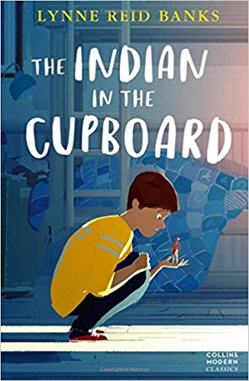

**LITERACY**

***‘Omri was deep in the book, frowning heavily, several minutes after the bell had rung.’***

**...follow the Y4 and 5 New national curriculum for English 2014 and**

*-* write a non-chorological report around different Native American Tribes

- use the novel's descriptive language to **write in the style of the author** and **develop their own imaginative narratives** building on their **spelling, punctuation and grammatical knowledge**

**-** write a character description about Little Bull including his outfit

- write a set of instructions on how to build a Native American structure.

**COMPUTING**

- use search technologies effectively – use programming software to develop programming skills

**GEOGRAPHY**

***‘These vegetables had, for some reason, been called The Three Sisters.’***

- use a map of America to **analyse where different Native American tribes travelled and lived**

-explore which natural resources the tribes had available and how this affected the native’s lifestyle.

**MUSIC with Mrs Pascal**

***‘Twin Stars was now crouched by the fire singing softly.’***

- **follow the Music Express** scheme Sum 1

*-* **follow the Music Express** scheme Sum 2

**SCIENCE**

**‘…journey they had made together though the unknown regions of time, space – proportion.’**

- compare and group materials by their properties

- look at mixing solids and liquids and reversing the process through evaporating, sieving and filtering.

- carry out fair tests and explain why these tests are fair.

**NUMERACY**

**‘…I’ve got enough money. Please…’**

- follow theY4 and 5 New national curriculum for mathematics 2014 and

*-* **develop greater fluency** and **make calculations** using formal written calculations**,**

- **solve problems** and find solutions and

- **reason and explain strategies** and understanding of their mathematical working out

**HISTORY**

**‘Iroquois Indians were sometimes called the ‘Five Nations’**

-explore the history and the culture of the Native Americans

-to research, compare and contrast different Native American tribes

**ART / DT**

***‘From the microscopic point of Boone’s pencil there developed a most amazing scene.’***

***-****explore Native American Art and sculpture work through different mediums.*

*-design and create Native American sculptures out of clay*

*-use nature to create Native American artwork*

[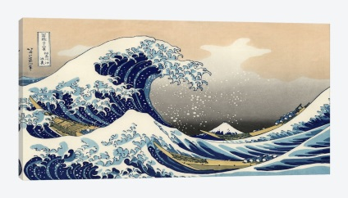](https://www.google.co.uk/url?sa=i&rct=j&q=&esrc=s&source=images&cd=&cad=rja&uact=8&ved=0ahUKEwiB_JylhqbRAhXINhoKHTC0CZMQjRwIBw&url=https://www.icanvas.com/greatwavekanagawaartprint.html&psig=AFQjCNH8wGjo6AcrDQWWtni_fuKMgoPaqA&ust=1483535426591760)

**Mr Sargeant**

**and**

**Mrs Winward**

**PHSE**

***‘”Brother”, he said, looking up at Omri with his fierce black eyes for the last time.’***

*-learn how to build their* ***resilience as a Growth Mindset*** *through lunch time nurture groups and school assemblies to create a ‘You can do it’ attitude.*