**MUSIC with Mrs Pascal**

***‘…the whole orchestra of the jungle was tuning up'p58***

- **follow the Music Express** scheme Spr 1

*Exploring…listening- Solar system*

*-* **follow the Music Express** scheme Spr 2 *Exploring… composition – At the movies*

**- Music appreciation** *: Debussey – Le Mer (The Sea)*

**RE with Mrs Clarke**

***'…not a miracle, just faith.' p161***

- explore **'Parables that Jesus told’**

- explore ‘**Caring for creation’**

**SPRING 2017**

**Base 4 ~ Y4/5**

**The children will...**

[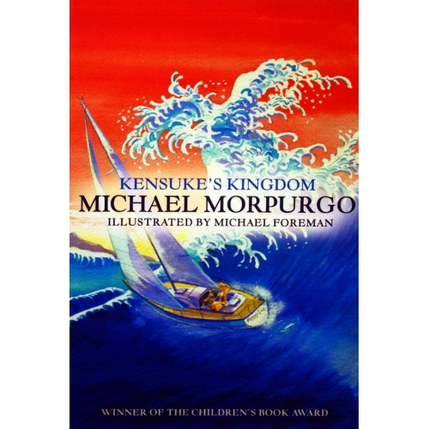](http://www.google.co.uk/url?sa=i&rct=j&q=&esrc=s&source=images&cd=&cad=rja&uact=8&ved=0ahUKEwicjrX29KXRAhXecVAKHUm5CigQjRwIBw&url=http%3A%2F%2Fwww.scarthinbooks.com%2Freviews-7-10-years%2Fattachment%2Fcopy-morpurgo-kensukes-kingdom-500x500%2F&psig=AFQjCNHw-jCzJmDw-veKq8ZyaF8FtsBM0w&ust=1483530744610140)

**LITERACY**

***‘It was on watch at night that I would often do my ‘English’ p22***

**...**follow theY4 and 5 New national curriculum for English 2014 and

*-* write a **balanced argument** on whether Michael should be allowed to spend a year away from school sailing around the world

- use the novel's descriptive language to **write in the style of the author** and **develop their own imaginative narratives** building on their **spelling, punctuation and grammatical knowledge**

**-** write an entry in a **ship’s log**

- explore **Haiku** **poetry** around the theme of the sea

- write a **letter from Kensuke** to his long lost family

- write **a biography** of the Japanese artist Hokusai

**COMPUTING**

***‘…at computers and what they could do’ p139***

- use search technologies effectively – Japan and its culture; Dr Kensuke Ogawa; travel distances

**GEOGRAPHY**

***'We could sail around the world. Africa. South America. Australia. The Pacific.' p10***

- use a world map to **chart the journey of the Peggy Sue**.

- develop understanding of **geographical terms** including longitude and latitude, hemisphere, equator, Tropic of Cancer and Capricorn

- learn about **Japan and Japanese culture**

-

-

**PE**

***‘Afterall, I had nowhere to swim to’ p 47***

***-****have a series of 8* ***swimming lessons***

***-****develop their* ***kicking skills and games to develop them*** *with Sportscape and Mr Sargeant*

**SCIENCE**

***'The sun in Africa is so big, so red'. p37***

**- develop their scientific skills** by posing and answering their own questions

- learn about the relationships between the Earth, Sun and Moon

**-** explore **forces** including gravity and friction

- investigate **solids, liquids and gases** and **changing states**

***‘Only when the sun shone and the sea had stopped its heaving, could we begin to dry out’ p18***

***-*** understand the **Water Cycle**

**NUMERACY**

***‘There were Maths Course books to get through’ p21***

- follow theY4 and 5 New national curriculum for mathematics 2014 and

*-* **develop greater fluency** and **make calculations** using formal written calculations**,**

- **solve problems** and find solutions and

- **reason and explain strategies** and understanding of their mathematical working out

**HISTORY**

***'We could just take off and sail around the world. There’s people who’ve done it'p9***

-create a timeline of famous journeys ‘around the world’

**ART / DT**

***'...One day you will be great artist like Hokusai’ p159***

- appreciate The Great Wave off Kawanaga

- recreate own ‘Great Wave’ in style of Hokusai

***‘he wrapped around dressing gown (a kimono) p103***

**-** explore the art of silk painting

- design & make a class kimono (DT / textiles)

[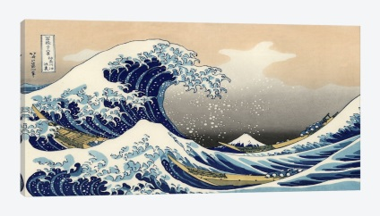](https://www.google.co.uk/url?sa=i&rct=j&q=&esrc=s&source=images&cd=&cad=rja&uact=8&ved=0ahUKEwiB_JylhqbRAhXINhoKHTC0CZMQjRwIBw&url=https://www.icanvas.com/greatwavekanagawaartprint.html&psig=AFQjCNH8wGjo6AcrDQWWtni_fuKMgoPaqA&ust=1483535426591760)

**Mr Sargeant**

**and**

**Mrs Winward**

**PHSE**

***‘We friends, but you do not tell me what you feel’ p 134***

***-****develop their understanding of*friendships through Friendship Terrace (Getting on and Falling Out)…***‘that she’d always keep on at a thing until she’d done it’ p14***

*-learn how to build their* ***resilience as a Growth Mindset***