Wrenbury Primary School
'...where we all matter'
Nantwich Road
Wrenbury
Nr Nantwich
Cheshire
CW5 8EN

Dear Parents/Carers,

I would like to welcome you and your child back to the new school year; I hope you enjoyed the holidays and the children are well rested for a busy term. It is an exciting time at Wrenbury, welcoming our new members of staff, especially Mrs Griffin, Mrs Peek and Mrs Taylor who will be joining us in Base 3.

Our Learning Journey for this term is based on a Michael Morpurgo text, ‘Running Wild’; alongside this text we will be utilising a range of other quality texts to support our writing. We will be undertaking a range of exciting and interesting activities to find out as much as we can about the Indonesian Rainforests and Animals. Please see the termly plan for an overview of some of the learning we will undertake. If you feel you can contribute towards our Learning Journey in any way (artefacts / books / photos, support in class with a particular skill etc.) it would be warmly welcomed.

Expectations
As the children are now in Key Stage 2 and year 4 are in their second year in Key Stage 2, it is now the time for the children to become more independent and responsible for their own learning. I will challenge and support your child in their learning, but will expect your child to do their very best and contribute positively to our class so that we all have a very rewarding and successful year. It is really important that we work together to help your child succeed both personally and academically.

Arrival at school
Good attendance is necessary for good progress. Please ensure your child arrives between 8:45 and 8:55am ready to start the day. Morning activities (Maths and Literacy based), which consolidate or challenge the children's learning, are set up for this time in readiness for registration of the class by 9am and a smooth transition into the literacy lesson.

Monies and messages
All monies and messages must come into school via myself to assist Mrs Rowlands in the office at the start of the day. It is important for the children to bring monies and messages in for themselves to help them become responsible and independent.

Outdoor clothing
We all know the weather is very changeable at this time of year. Therefore, appropriate clothing must be in school; in particular, a warm/waterproof coat should be brought/worn to school every day.

Dinner Money
If your child wishes to have a school dinner this year it will be at a cost of £2.30 per day, please pay dinner money as soon as possible to support Mrs Warner in the kitchen.

Snack
Snack will be available for Mrs Warner at break times each day, but if your child wants to bring a snack from home please ensure that it is a healthy snack as we are promoting healthy living.

Base 3 Timetable
We will have daily maths and literacy lessons with the afternoons dedicated to our Learning Journey, which will include science, art, design and technology, geography, history, music and ICT. There may be times where some of these subjects will be linked due to the nature of the task.
On Thursday afternoon the children will receive an hour of RE delivered by Mrs Clarke, followed by an hour of Music delivered by Mrs Pascal.
The children will continue to receive a 30 minute French lesson with Madame Sharpe, in their year groups, on Friday mornings.

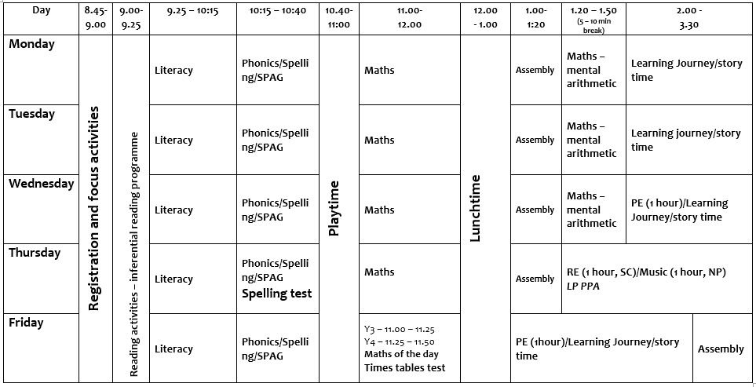

PE
PE kits (red top, black shorts/trousers, trainers) must be in school on a Wednesday and Friday for our PE lessons. PE kits should then be taken home to be washed over the weekend and brought back into school on Monday. There may be opportunities during our Learning Journey lessons for additional PE sessions so PE kits need to be in school all week. The children will be reminded that it is their responsibility to make sure PE kits are in school.

Base 3 will be going swimming this year, dates will be confirmed closer the time; this information will be given to you as soon as we can.

Homework
Once the children are settled and we have gained baseline assessments, regular homework will be sent on the following days:
- Literacy and Maths
Monday (MyMaths or alternative task) - Completed by Friday
Thursday (usually Literacy based) – Completed by Tuesday

- Times Tables -Test day Friday
To be practised at least 5 times throughout the week before the test.

- Spellings -Test day Thursday
To be practised 5 times throughout the week before the test.

- Daily Reading
Reading should be done daily, for at least 15 minutes, with comments written in the reading record.

Upcoming events
Y3 and Y6 will be participating in Singfest '17 'Popera' in March and will start to learn the songs after a massed choir rehearsal on Thursday 6th October. Again a letter will be sent out about the rehearsal.
Y4 and year 5 will begin their brass tuition on the 15th September, which is an excellent opportunity to develop a new skill.
Y4 will take part in the Bikeability programme on the 21st September, more details to follow.

Home time Arrangements
It is very important that the Home Time Arrangement sheet is completed and brought back to school. Please do notify me of any changes to home time arrangements at Meet or Greet in the morning or by phoning the school office.

Open door
My door is always open and I am always very happy to help should you have any concerns, wish to share information that is relevant to your child's well-being or require additional information regarding your child and their learning or progress. I will be on the gate every morning or you can arrange a time to meet with me at a time that is convenient for the both of us.

There is a Pastoral Meeting booked for XXX, which will give you a chance to meet me and to find out, in more detail, about the rhythms, routines and expectations for your child in Base 3. I very much hope you will be able to attend as important information will be given about your child’s education.

I am looking forward to an exciting and enjoyable year with you and your child.

Miss Phillips

